Project Report
Vaibhav saini
24BCE11376
Open Source Software — Firefox

Part A — Origin and Philosophy
Historical Background
During the 1990s, Microsoft's dominance in the browser market was absolute. Internet Explorer, their own innovation, came pre-installed with every Windows operating system, thereby locking out any real challengers. Why bother seeking for something else when a perfectly decent browser was already there, ready to use?
What Were the Developers Trying to Achieve?
The team behind what would become Firefox had a clear vision: design a browser that was rapid, lightweight, independent of corporate interests, and fully aligned with open web standards. Their goal was to keep the internet a place everyone could use, where everything worked together, and where things continually changed.
How They Did It
To undermine Microsoft's authority, Netscape did something extraordinary in 1998: they published their browser's source to the world. This open-source method kicked with the Mozilla Project, a community-driven project with a single mission: "Build a browser built by its users."
In 2002, a group within Mozilla released a minimalist browser named Phoenix. After a trademark issue necessitated a name change to Firebird, the project achieved a critical point in 2004 with the official introduction of Firefox. Unlike the bulkier browser packages of the time, Firefox was commended for its rapidity and minimalist appearance.

Firefox 1.0 introduced several innovative features. Tabbed surfing enables users open several webpages in one window.
A built-in pop-up blocker, greater security settings, and a customized extension system allowed users much more control over their experience. These traits help Firefox threaten Internet Explorer's supremacy and revive browser-market rivalry.
Licensing
Firefox is released under the Mozilla Public License (MPL) version 2.0 — a free, open-source license that offers users the ability to use, change, and redistribute the software while insuring that the original codebase keeps its open character.
The Four Freedoms of Free Software - Does MPL Support Them?
The MPL 2.0 license protects the four key freedoms recognized in free software philosophy:
1. The flexibility to run the software for any reason
2. The flexibility to explore and learn how it works
3. The freedom to make improvements to the program
4. The freedom to share copies, whether original or modified
Can a Company Modify Firefox and Keep Those Changes Private?
A corporation may distribute a modified version of Firefox, but it cannot keep all its changes behind closed doors. Under MPL 2.0’s restricted copyleft restrictions, any changes made directly to existing Firefox source files must be provided under the same license. That said, totally new proprietary files that the corporation adds can stay private.
GPL vs. MIT: A Comparison, and Which Would You Choose?
The GNU General Public License (GPL) operates as a strong copyleft license, meaning any software generated using GPL-covered code must itself be shared as free and open source. This insures that the "freedom" propagates along the entire program lineage.
By comparison, the MIT License imposes almost no restrictions. Developers may embed MIT-licensed code into proprietary products, alter it at freely, or redistribute it commercially. The single mandatory need is to maintain the original copyright notice.
If forced to choose between the two, MIT would be the preferable. It places fewer constraints on adoption and appeals to a larger spectrum of users – even enterprises who need to incorporate code into closed-source systems. Wider acceptance typically correlates to wider influence. 'Free as in Free Beer' vs. 'Free as in Freedom' - What’s the Difference? "Free as in free beer" only means no monetary expense is required, but it says nothing about what you can do with the software. Redistribution or change may still be forbidden. "Free as in freedom," on the other hand, refers to the rights offered to the user — the opportunity to use, study, alter, and share software, irrespective of pricing.
Firefox is a textbook example of the latter. Its source code is publicly accessible at no cost, and developers are enabled to design derivative products such as LibreWolf and Waterfox, which they may also offer freely.
The Ethics of Open Source Should All Software Be Open Source?
The question does not have a plain yes-or-no answer. In environments where security is crucial — such as financial infrastructure, defense systems, or government networks — publicly available source code might become a template for attackers aiming to exploit weaknesses. Selective use of closed-source components can provide an additional defensive layer.
On the flip side, open-source code benefits from collective review. A bigger pool of developers evaluating the code implies vulnerabilities are more likely to surface and be patched. Highly secure systems like the Linux kernel indicate that open-source software is not necessarily less safe.
A nuanced strategy — one that balances transparency with carefully managed anonymity where truly necessary — is likely more realistic than an all-or-nothing posture.
Is It Ethical for a Company to Profit From Community-Built Software?
Companies like Red Hat, Google, and Meta have developed huge commercial companies on top of the Linux kernel — a project that Linus Torvalds first distributed as a personal experiment. This strategy is ethically justifiable provided that the corresponding open-source license is honored and due attribution is given.
The ethical difficulties occur when firms pull out credit, misuse donor effort without any reciprocal investment, or infringe license limitations. Where corporations contribute back through contributions, documentation, or investment, the relationship becomes mutually beneficial rather than exploitative. 'Standing on the Shoulders of Giants' - Does Open Source Enable or Undermine Innovation?
In the realm of software, "standing on the shoulders of giants" underlines how every new generation of developers inherits a huge toolbox established by those who came before, allowing them to neglect the basic tasks and direct energy into innovative concerns.
Open source often accelerates rather than hinders innovation. Access to mature, well-tested codebases allows individuals and organizations to prototype and iterate fast. Operating systems, computer languages, and web browsers all owe their existence in part to this history of exchanging knowledge.
The counter-argument — that excessive dependence on existing code stifles truly innovative thought — has value, but is overwhelmed by the evidence of how much innovation has been sparked precisely by open-source foundations
.Part B — Linux Footprint
Installation Approach
The operating environment used for this section is Debian, a widely adopted Linux distribution. Firefox on Debian is installed via apt (Advanced Package Tool), a package management utility that retrieves and installs software from official repositories.
Screenshots
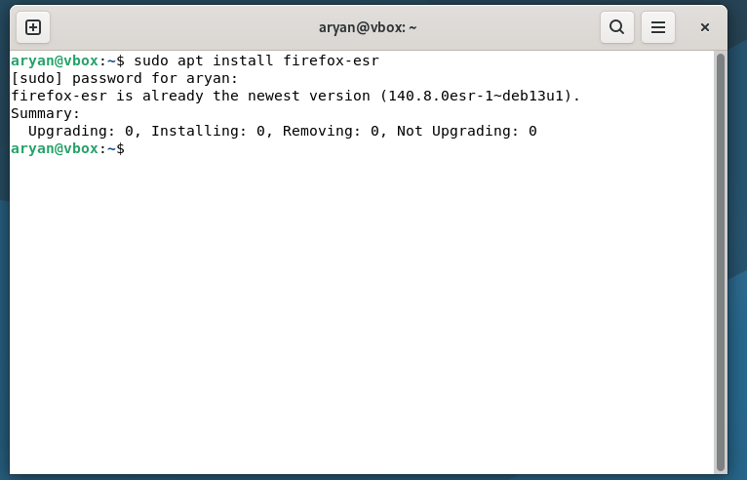
Key Directories
1) Binaries
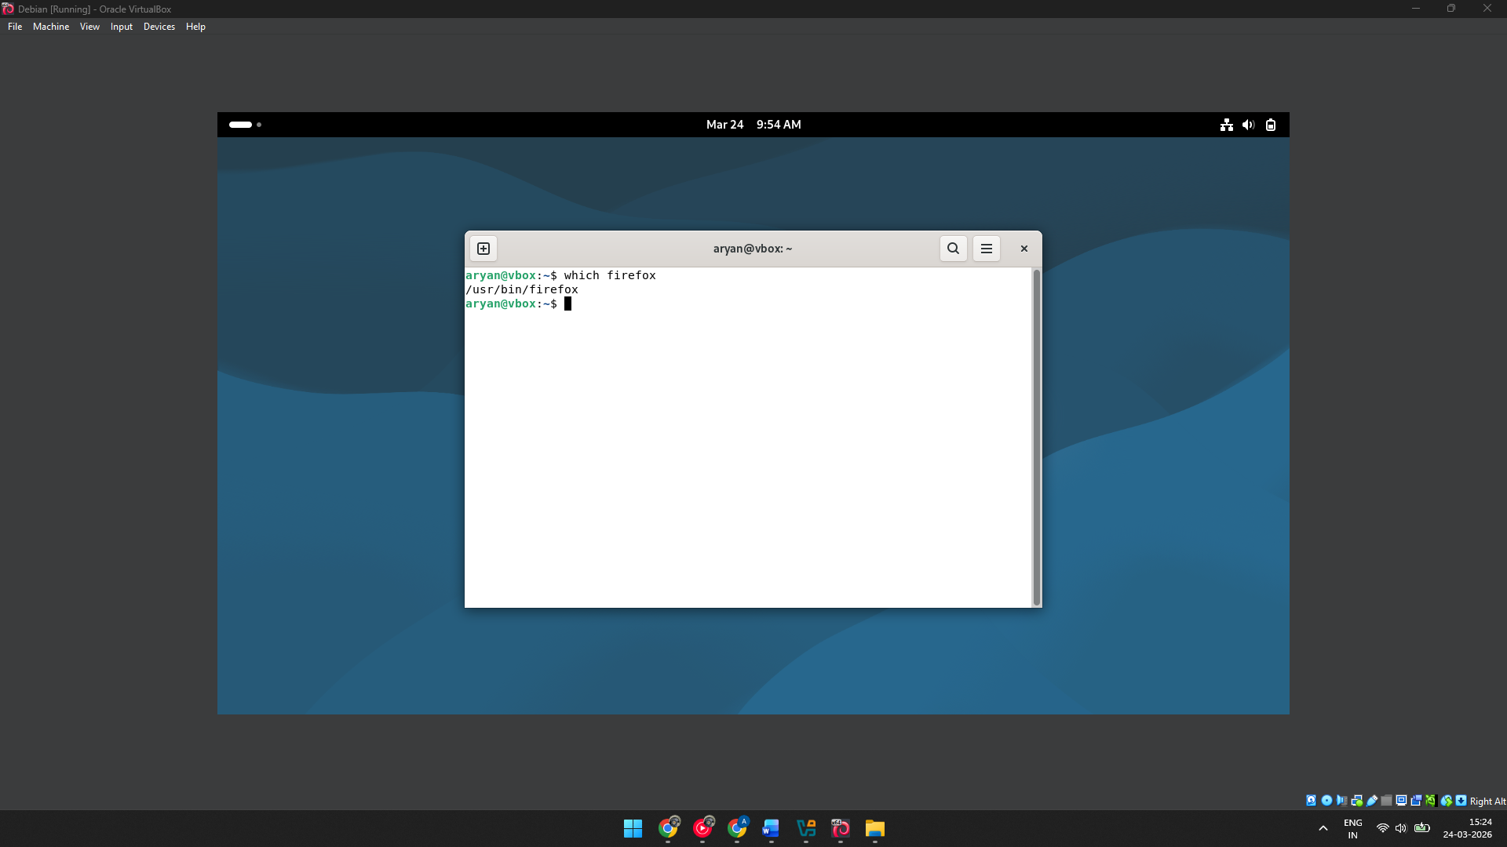
2) Program Files
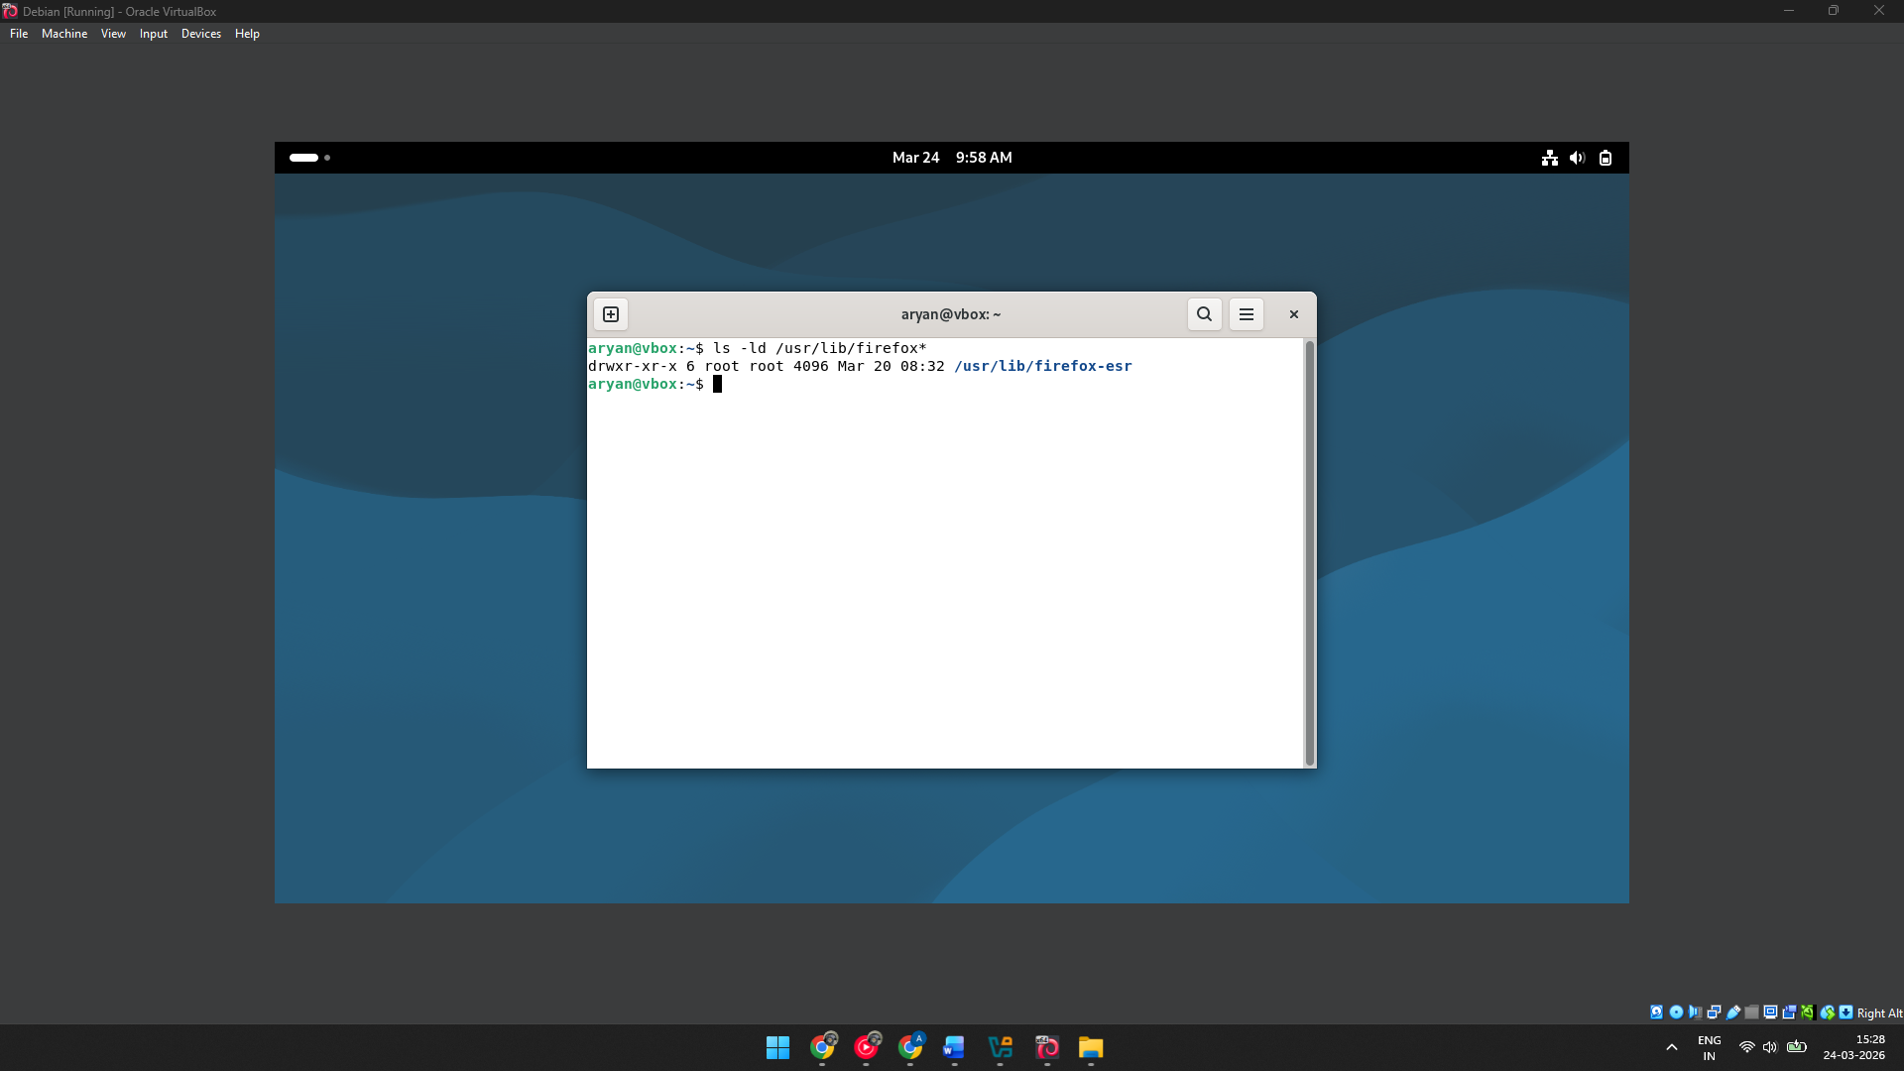
3) Configuration Files
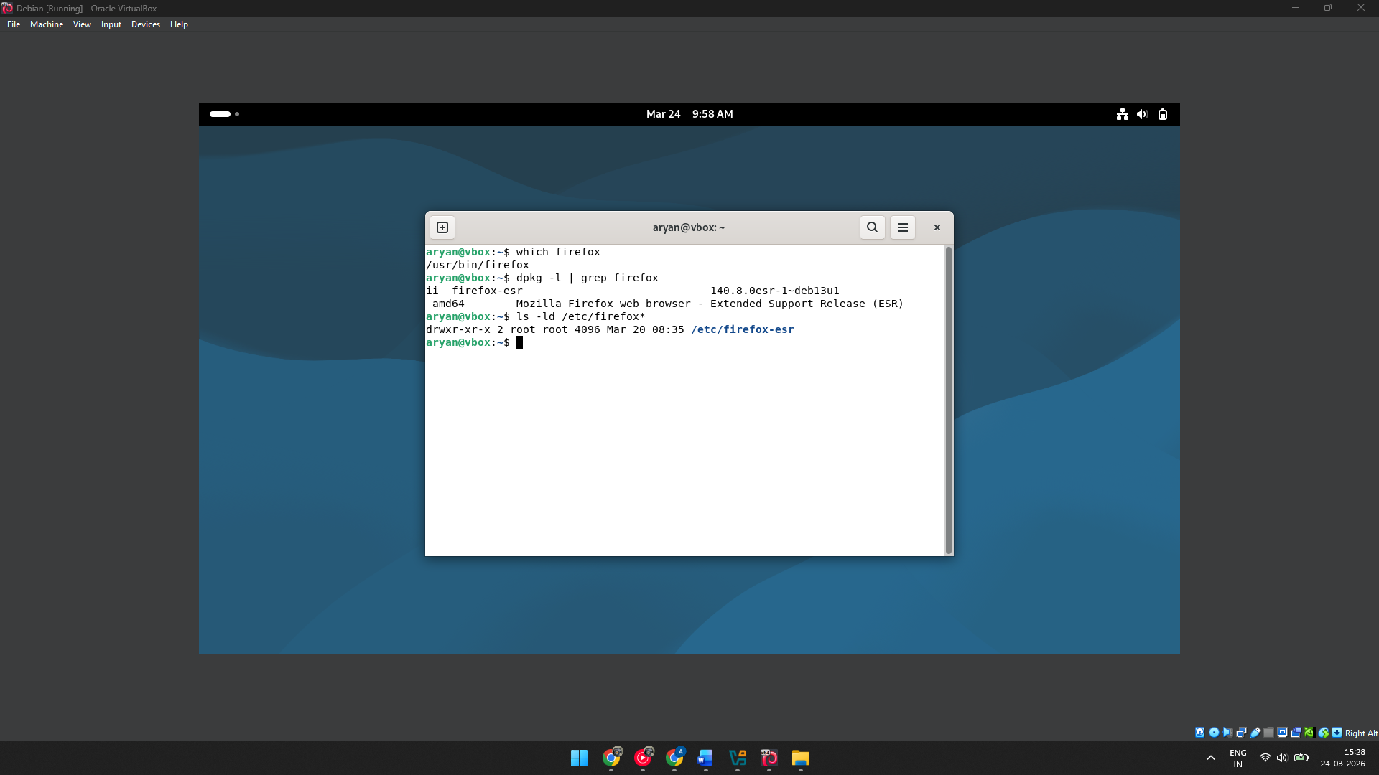
4) User Configuration / Profiles
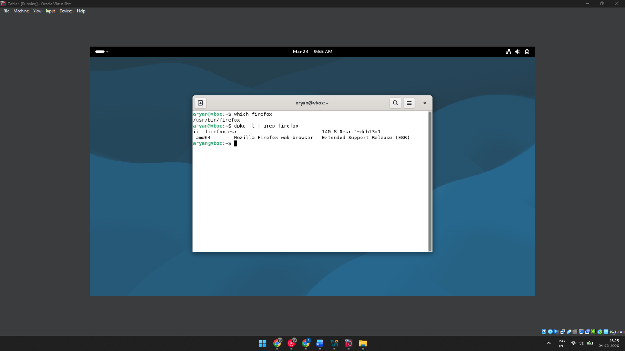
User and Group Ownership
Firefox does not function under a privileged or specialized system account. Instead, it operates under whichever user account is currently active. For instance, when launched by the account vaibhav, the browser process adopts that user’s identity and group membership. This may be validated by executing ps aux | grep firefox, which reveals process ownership.
Why This Is a Security Advantage
Running a browser as an ordinary user — rather than as root — reduces the blast radius of a successful assault. If an adversary were to exploit a browser-level vulnerability, they would be constrained to the access permissions of the logged-in user, preventing system-wide compromise. This structure reflects the notion of least privilege, a cornerstone of excellent Linux security design.
Part C — The FOSS Ecosystem
Open-Source Dependencies

Firefox is built on top of numerous open-source components, including:
• Gecko — the rendering engine at Firefox's core
• Rust — a systems programming language used in performance-critical browser components
• SQLite - a lightweight database engine powering bookmarks and browsing history
• NSS (Network Security Services) - cryptographic libraries providing safe connections
• GTK — the graphical toolkit used for Firefox's Linux interface

What Firefox Has Made Possible

Because Firefox is open source, it has given rise to a range of derivative browsers. Projects like Waterfox, LibreWolf, and the Tor Browser each change the Firefox source to target efficiency, increased privacy, or anonymity, respectively. Beyond forks, Firefox's sophisticated extension architecture has created a massive ecosystem of add-ons targeting productivity, developer tooling, and privacy protection. These outcomes demonstrate how a permissive codebase can stimulate totally new lines of development.

Firefox and the Web Stack

Firefox does not sit within the traditional LAMP stack (Linux, Apache, MySQL, PHP), which describes a server-side architecture. Instead, it occupies the client side of that equation — the interface by which end users engage with applications produced on that infrastructure. For developers, Firefox is also a diagnostic instrument: its built-in DevTools allow real-time analysis of HTML, CSS, JavaScript, and network activity. By rigorously adopting open web standards, Firefox functions as a conduit between users and the server-side technology they connect to.

Community and Governance

Firefox is maintained under the supervision of the Mozilla Foundation and its commercial arm, the Mozilla Corporation. A global volunteer community offers bug reports, code patches, and documentation upgrades. Communication takes occur through mailing lists, web forums, IRC channels, and the Bugzilla trouble tracker. The Mozilla Foundation also convenes conferences to bring contributors together and strengthen the project's direction.
Part D — Open Source vs. Proprietary
The following table draws a structured comparison between Firefox and Google Chrome across several key dimensions:

Dimension | Firefox (Open Source) | Google Chrome (Proprietary)
Cost | Free and open source | Free but proprietary
Security | Source code is publicly auditable | Closed source; limited transparency
Support & Reliability | Community-backed + Mozilla Corporation support | Robust enterprise-level backing from Google
Freedom to Modify | Users are permitted to modify and redistribute | Modification by end users is not permitted
Community vs Corporate Control | Community-driven development model | Fully corporate-controlled
Overall Verdict | Transparent, highly customizable | Polished and widely adopted

Conclusion
Firefox's open architecture makes its inner workings fully accessible to study and open to collaborative development. Google Chrome, by comparison, is the product of a single corporate entity with limited outside input, which constrains how much flexibility users truly have.
While Chrome benefits from the weight of Google's resources and integration with its services, Firefox stands out as the stronger alternative for individuals who value privacy, adaptability, and an open web. It may not equal Chrome's intimate relationship with Google’s ecosystem, but it gives something potentially more important: full user autonomy. For anyone interested in both using and contributing to open-source software, Firefox represents a compelling real-world platform
.

Shell Scripts Tasks
Script 1 — System Identity Report (Unit 1 & 2)
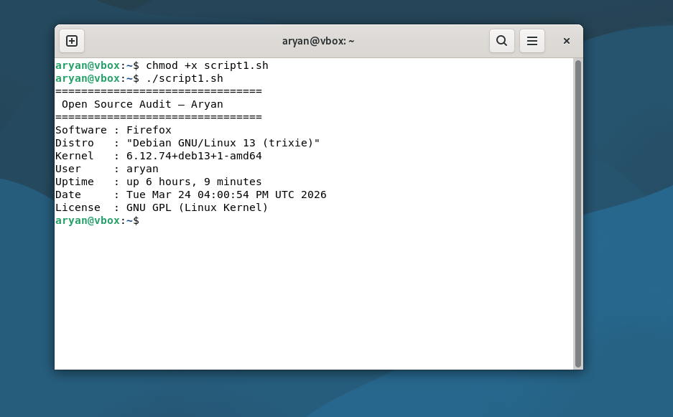
#!/bin/bash
# Script 1: System Identity Report
# Author: vaibhav | Course: Open Source Software

STUDENT_NAME="vaibhav"
SOFTWARE_CHOICE="Firefox"
KERNEL=$(uname -r)
USER_NAME=$(whoami)
UPTIME=$(uptime -p)
DATE=$(date)
DISTRO=$(cat /etc/os-release | grep PRETTY_NAME | cut -d= -f2)

echo "================================"
echo " Open Source Audit --- $STUDENT_NAME"
echo "================================"
echo "Software : $SOFTWARE_CHOICE"
echo "Distro : $DISTRO"
echo "Kernel : $KERNEL"
echo "User : $USER_NAME"
echo "Uptime : $UPTIME"
echo "Date : $DATE"
echo "License : GNU GPL (Linux Kernel)"
Script 2 — FOSS Package Inspector
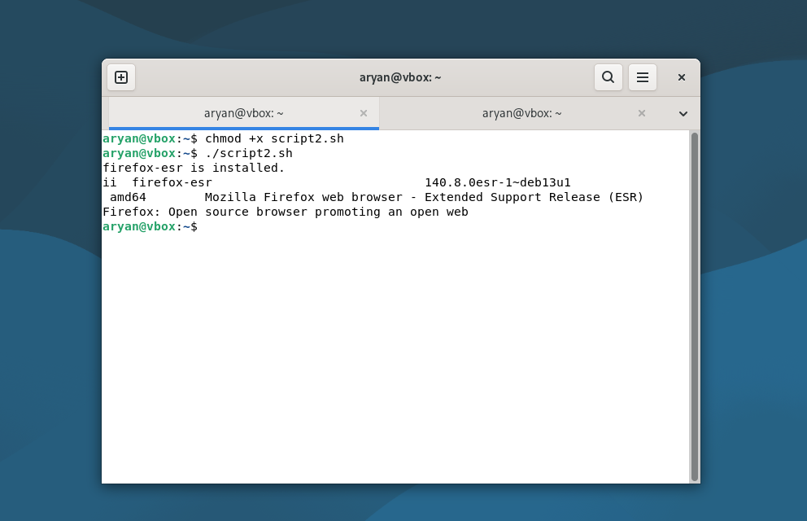
#!/bin/bash
# Script 2: FOSS Package Inspector
PACKAGE="firefox-esr"

if dpkg -l | grep -q $PACKAGE; then
echo "$PACKAGE is installed."
dpkg -l | grep $PACKAGE
else
echo "$PACKAGE is NOT installed."
fi

case $PACKAGE in
firefox|firefox-esr) echo "Firefox: Open source browser promoting an open web" ;;
vlc) echo "VLC: Open source multimedia player" ;;
git) echo "Git: Distributed version control system" ;;
apache2) echo "Apache: Web server powering the internet" ;;
esac
Script 3 — Disk and Permission Auditor
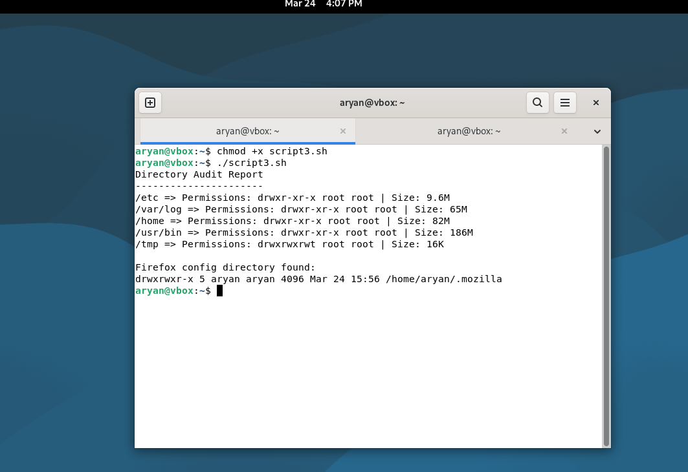
#!/bin/bash
# Script 3: Disk and Permission Auditor
DIRS=("/etc" "/var/log" "/home" "/usr/bin" "/tmp")

echo "Directory Audit Report"
echo "----------------------"

for DIR in "${DIRS[@]}"; do
if [ -d "$DIR" ]; then
PERMS=$(ls -ld $DIR | awk '{print $1, $3, $4}')
SIZE=$(du -sh $DIR 2>/dev/null | cut -f1)
echo "$DIR => Permissions: $PERMS | Size: $SIZE"
else
echo "$DIR does not exist"
fi
done

# Firefox config directory check
FIREFOX_DIR="$HOME/.mozilla"
if [ -d "$FIREFOX_DIR" ]; then
echo ""
echo "Firefox config directory found:"
ls -ld $FIREFOX_DIR
else
echo "Firefox config directory not found."
fi
Script 4 — Log File Analyzer
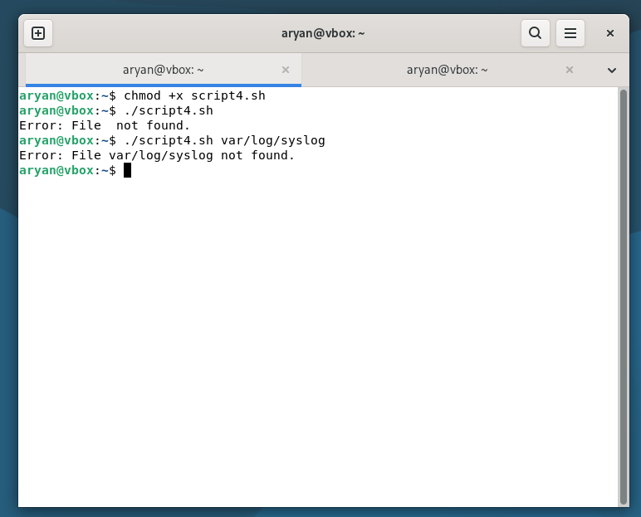
#!/bin/bash
# Script 4: Log File Analyzer
LOGFILE=$1
KEYWORD=${2:-"error"}
COUNT=0

if [ ! -f "$LOGFILE" ]; then
echo "Error: File $LOGFILE not found."
exit 1
fi

while IFS= read -r LINE; do
if echo "$LINE" | grep -iq "$KEYWORD"; then
COUNT=$((COUNT + 1))
fi
done < "$LOGFILE"

echo "Keyword '$KEYWORD' found $COUNT times in $LOGFILE"
echo ""
echo "Last 5 matching lines:"
grep -i "$KEYWORD" "$LOGFILE" | tail -5
Script 5 — Open Source Manifesto Generator
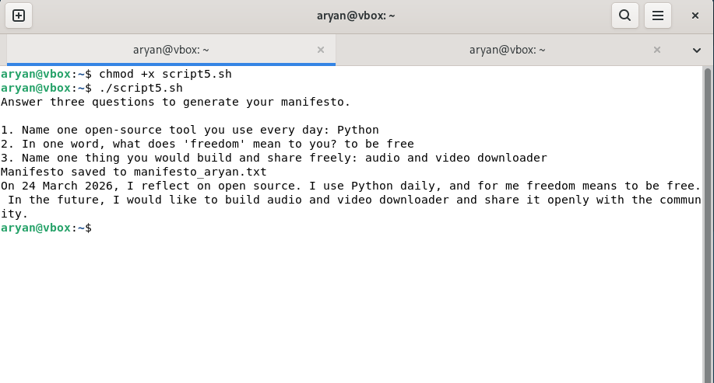
#!/bin/bash
# Script 5: Open Source Manifesto Generator
echo "Answer three questions to generate your manifesto."
echo ""
read -p "1. Name one open-source tool you use every day: " TOOL
read -p "2. In one word, what does 'freedom' mean to you? " FREEDOM
read -p "3. Name one thing you would build and share freely: " BUILD

DATE=$(date '+%d %B %Y')
OUTPUT="manifesto_$(whoami).txt"

echo "On $DATE, I reflect on open source. I use $TOOL daily, and for me freedom means $FREEDOM. In the future, I would like to build $BUILD and share it openly with the community." > $OUTPUT
echo "Manifesto saved to $OUTPUT"
cat $OUTPUT

